Ideation Phase
Empathize & Discover

Date
Team id | NM2025TMID02994
Project name | LEASE MANAGEMENT
Maximum mark

Empathy Map Canvas – Lease Management
The Empathy Map Canvas helps understand the needs, feelings, and challenges of users involved in lease management (e.g., property managers, tenants, or leasing officers).
Section | Key Points (for Lease Management)
1. Says | “It’s hard to track lease renewals.” / “We need reminders for rent payments.”
2. Thinks | Worried about compliance, data accuracy, and missed deadlines.
3. Does | Uses spreadsheets, emails, or paper files to manage leases.
4. Feels | Stressed, overwhelmed, and frustrated with manual processes.
5. Pains | Time-consuming tasks, human errors, missed payments, lack of visibility.
6. Gains | Wants automation, centralized data, timely alerts, and easy reporting.

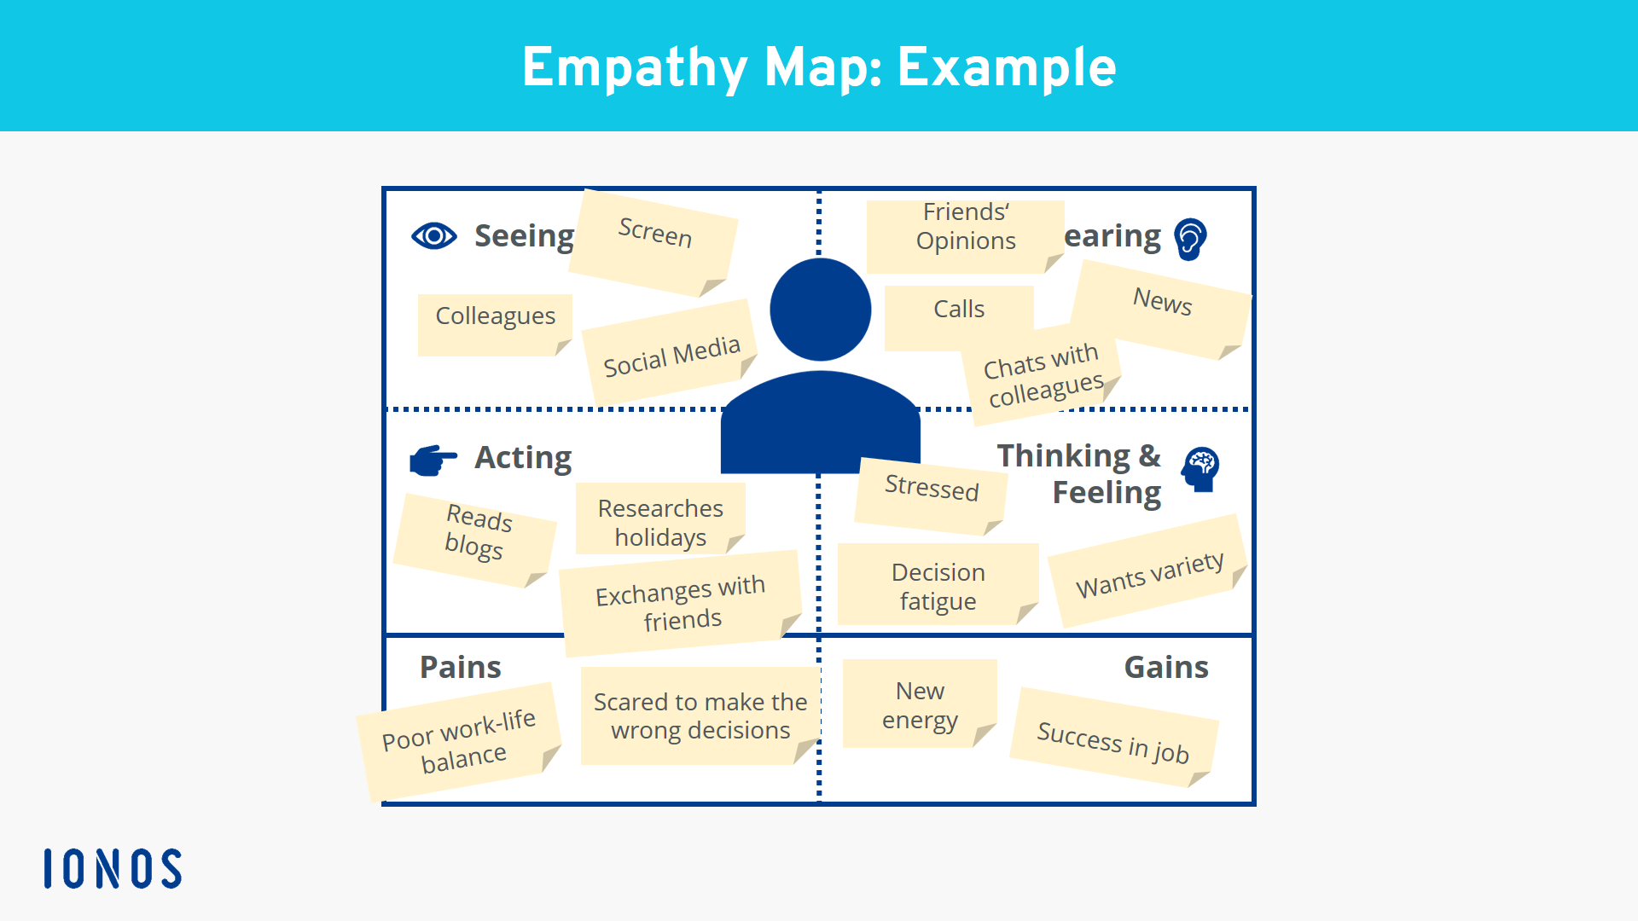

Food Ordering & Delivery Application – Analogy for Lease Management
A Food Ordering & Delivery App and a Lease Management System share similar process flows in terms of tracking, automation, and user experience.
Aspect | Food Ordering App | Lease Management System
User Action | Customer places an order | Tenant or owner creates a lease
Tracking | Order status updates (preparing, out for delivery) | Lease lifecycle tracking (active, renewal, expiry)
Notifications | Alerts for delivery time or offers | Alerts for rent due, renewal dates, maintenance
Payment | Online payment & receipts | Rent collection & payment tracking
Dashboard | Order history & analytics | Lease portfolio overview & reports
Automation | Suggests favorite meals or reorders | Automates renewals & compliance reports

